

Mid-Curriculum Project

InnoMed Startup Company

1

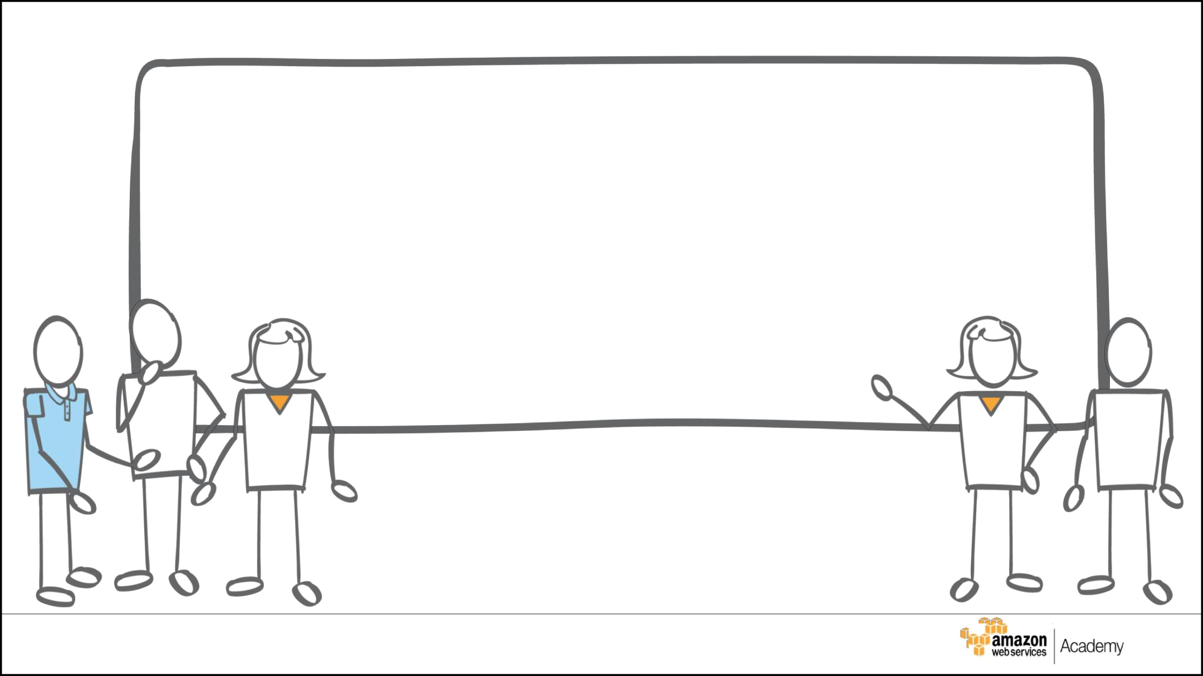
Introduction and Overview

© 2017, Amazon Web Services, Inc. or its Affiliates. All rights reserved. ₂


Introduction

- InnoMed is a startup software as a service (SaaS) company.

- It has built an online medical social networking and diagnosis assistance application for users in APAC, the US, and Europe.

- The application connects patients and doctors to allow online appointments, remote consultation, remote diagnosis, electronic prescription transfer, and payment services.

- The application allows customers to upload documents and images. Text is extracted from documents, and images are converted into multiple formats.

- The application has not yet been launched publically.

© 2017, Amazon Web Services, Inc. or its Affiliates. All rights reserved. ₃

Overview – Current Environment

- InnoMed’s development and test infrastructure is deployed with a server hosting company.

- InnoMed uses Microsoft Windows servers to host their web and application tiers with Microsoft SQL Server Standard Edition backend databases.

- The application launch date is coming soon and InnoMed expects many users to start using the application.

- InnoMed has decided to use cloud technologies to support its rapid growth.

- InnoMed has hired you to architect an infrastructure in AWS to meet their application needs.

© 2017, Amazon Web Services, Inc. or its Affiliates. All rights reserved. ₄

Overview – Requirements

InnoMed plans to move their application into AWS.

The plan includes:

- Configuring access permissions to conform with AWS best practices.

- Configuring auditing to track all user actions.

- Building networks that conform to AWS best practices while providing all the necessary network services to the applications in their different environments.

- Building an architecture that matches the current architecture at the server hosting company and that can handle doubling the number of servers.

- Ensuring that no code changes are required.

© 2017, Amazon Web Services, Inc. or its Affiliates. All rights reserved. ₅

Current Architecture

6

Current Architecture

Web Tier

- Two physical servers (Two CPUs / 4-GB memory)

- Microsoft Windows 2016 Base with IIS

- HAProxy load balancer used to balance traffic between the web servers Application Tier

- Two physical servers (Four CPUs / 16-GB memory)

- Microsoft Windows 2016 Base with IIS

- HAProxy load balancer used to balance traffic between app servers Database Tier

- One physical server (Eight CPUs / 32-GB memory / 5-TB storage)

- SQL Server Standard Edition – v12.xx

- Microsoft Windows 2016 Base

- DBAs access and manage the database, but no RDMBS or advanced configuration is required.

© 2017, Amazon Web Services, Inc. or its Affiliates. All rights reserved. ₇

Requirements

8

Requirements – User Authentication (1 of 2)

- Users with access to AWS are in three groups:

• | System Administrator group: | 2 users
• | Database Administrator group: | 2 users
• | Monitor group: | 4 users

  - Monitoring infrastructure resources for the application (EC2, S3, RDS)

- Follow AWS best practices for distributing permissions.

- The InnoMed application must read and write to S3 buckets.

© 2017, Amazon Web Services, Inc. or its Affiliates. All rights reserved. ₉

Requirements – User Authentication (2 of 2)

- A password policy should enforce the following:

  - A password with at least 8 characters, 1 uppercase and 1 lowercase letter,

    - number, and 1 special character

  - Forced password change every 90 days

  - No re-use of the previous three passwords

- All administrators require programmatic access and AWS Management Console access.

  - When signing in to the console, each administrator is required to provide a user name, a password, and a random generated code provided by the Virtual MFA.

- All other users should only have AWS Management Console access, using a combination of user name and password.

© 2017, Amazon Web Services, Inc. or its Affiliates. All rights reserved. ₁₀

Requirements – Auditing

Administrators must be able to track every AWS action in the account, including:

- Every service or object that was created or configured.

- The user who created the object or configured the service.

- The interface used for each creation or configuration action.

  - For example: AWS Management Console or CLI

- The source of each creation or configuration action.

  - For example: IP address or DNS alias

© 2017, Amazon Web Services, Inc. or its Affiliates. All rights reserved. ₁₁

Requirements – Network and Security (1 of 2)

The new architecture must conform to AWS best practices.

This includes:

- Achieve high availability for all tiers to reduce downtime.

- Control access to the applications and limit public entry points.

- Minimize IP address usage to reduce the attack surface.

- Maintain separate networks for InnoMed’s development/testing environment and production environment.

© 2017, Amazon Web Services, Inc. or its Affiliates. All rights reserved. ₁₂

Requirements – Network and Security (2 of 2)

The new architecture must conform to AWS best practices.

This includes:

- The web tier load balancer can receive requests from the Internet on port 80.

- Web tier servers can receive requests from the web tier load balancer only on port 80.

- The Application Load Balancer can receive requests from web tier servers only on port 8080.

- Application tier servers can receive requests from the application tier load balancer only on port 80.

- Database servers can receive requests from application servers only on port 1433.

© 2017, Amazon Web Services, Inc. or its Affiliates. All rights reserved. ₁₃

Requirements – Web Tier and Application Tier

- All the instance names in the web tier should be tagged as Key =

Name and value = web-tier.

- All the instance names the in application tier should be tagged as Key = Name and value = app-tier.

- All instances in the application tier must support EBS optimization.

- Load balancers for web tier and application tier must support HTTP, HTTPS, and TCP protocols.

© 2017, Amazon Web Services, Inc. or its Affiliates. All rights reserved. ₁₄

Requirements – Business Continuity

The new architecture should be designed for business continuity.

This includes:

- The web and application tiers should be self-healing.

  - If a server becomes unavailable it will be replaced by a new server.

  - A server is considered to be unavailable if the operating system or application fails to respond.

- The database tier should support Multi-AZ deployment.

- The architecture should handle doubling the number of servers to support its rapid growth.

© 2017, Amazon Web Services, Inc. or its Affiliates. All rights reserved. ₁₅

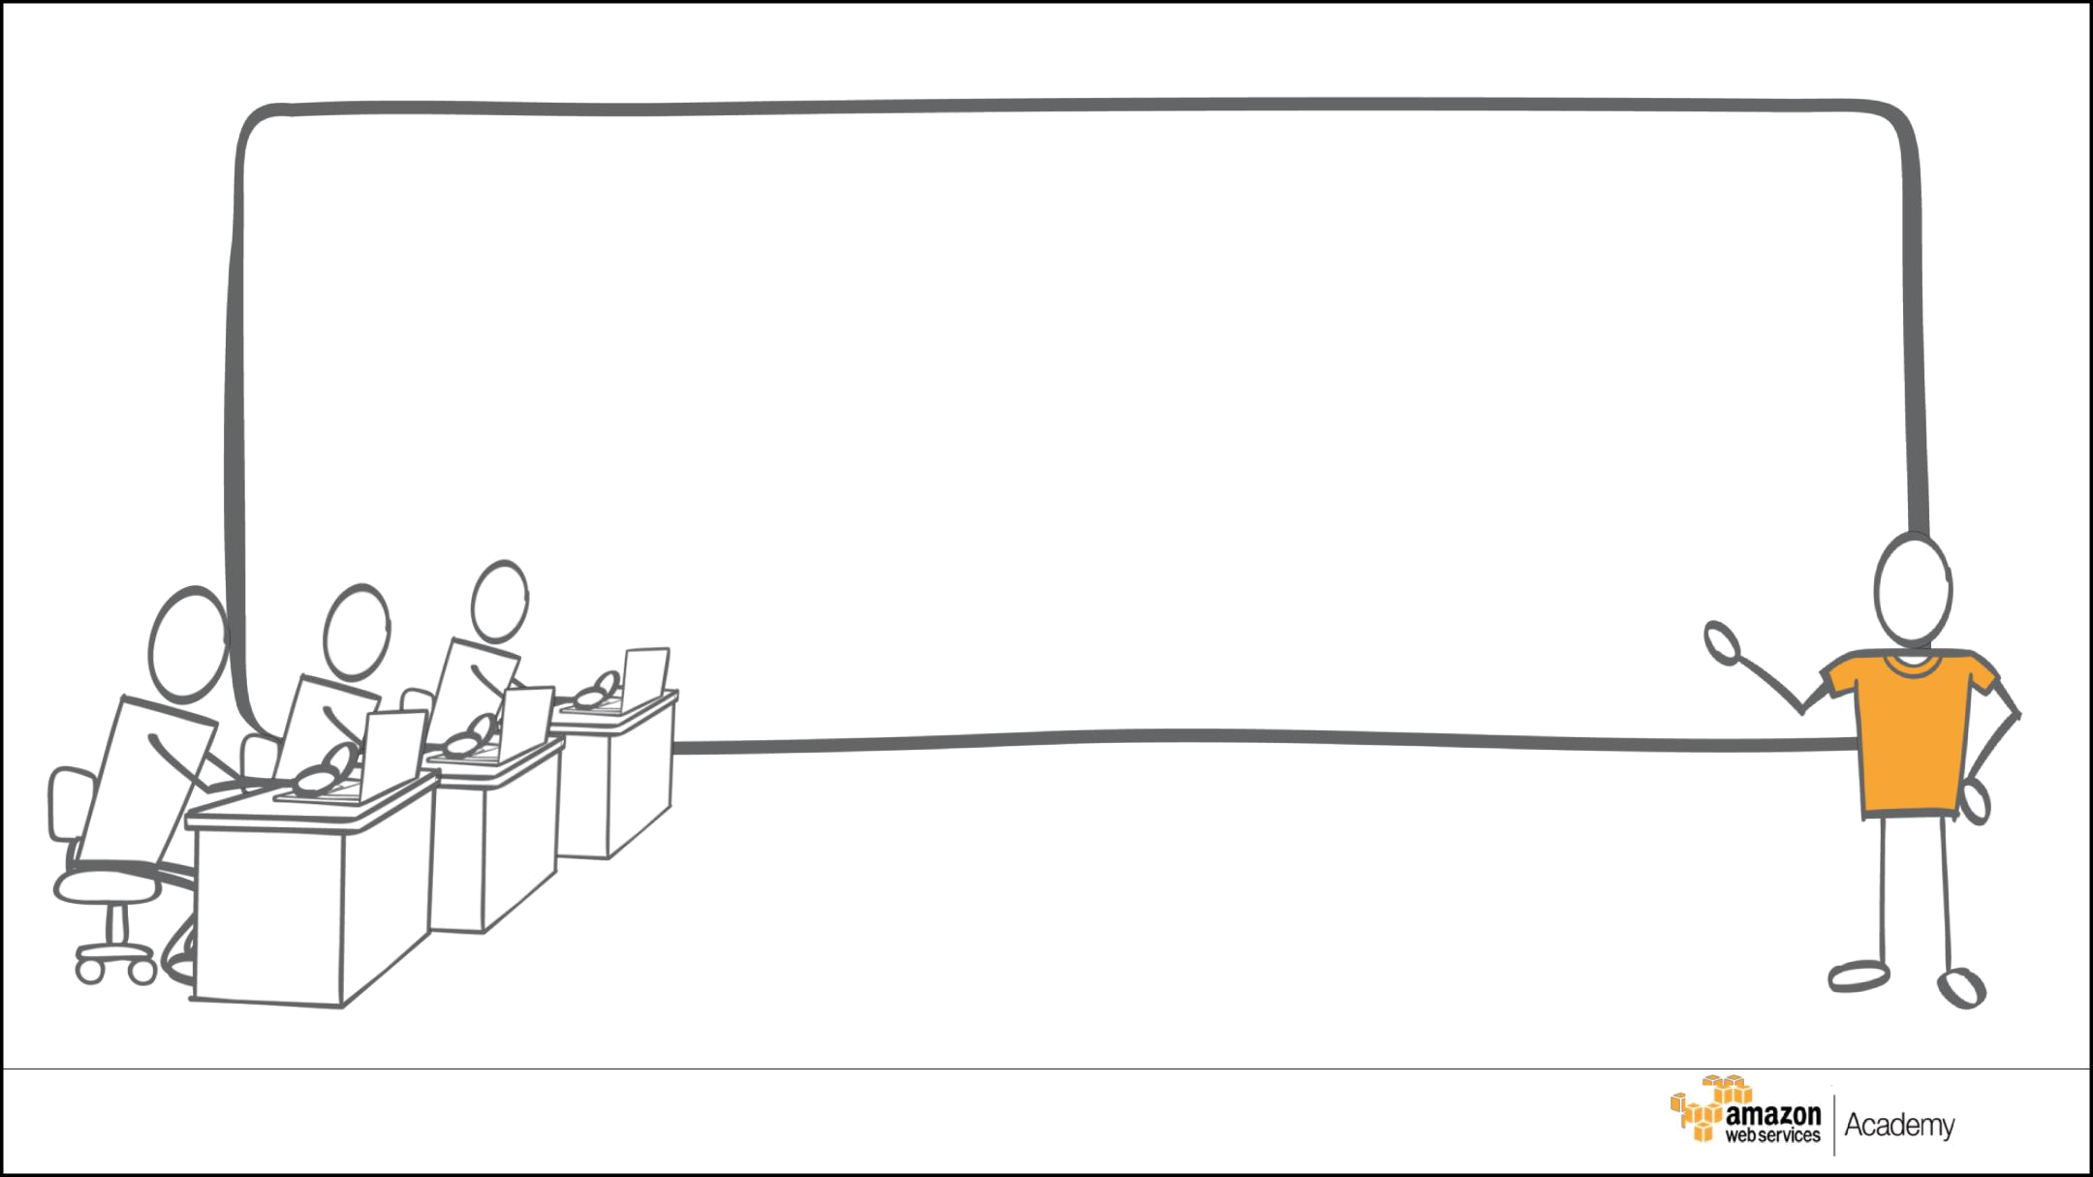

Solution Template

16

Which Services Will You Use?

© 2017, Amazon Web Services, Inc. or its Affiliates. All rights reserved. ₁₇

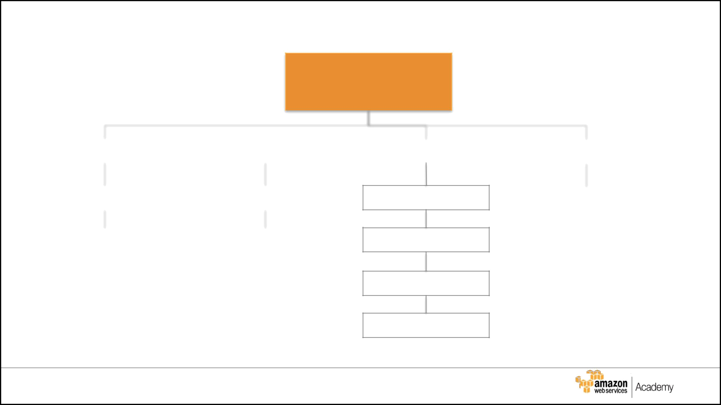
Users, Groups, and Roles

InnoMed Account

Group: |  |  |  |  | Group: |  |  |  |  |  | Group: |  |  |  |  |  |  | Role:
 | System Administrator group1 |  |  |  |  | Database Administrator group2 |  |  |  |  |  | Monitor group1 |  |  |  |  |  |  | Group manager
 |  |  |  |  |  |  |  |  |  |  |  | Monitor group2
 | System Administrator group2 |  |  |  |  | Database Administrator group2 |  |  |  |  |  | Monitor group3
 |  |  |  |  |  |  |  |  |  |  |  |  |  | Monitor group4

Use the chart to document users, groups, and roles created.

© 2017, Amazon Web Services, Inc. or its Affiliates. All rights reserved. ₁₈

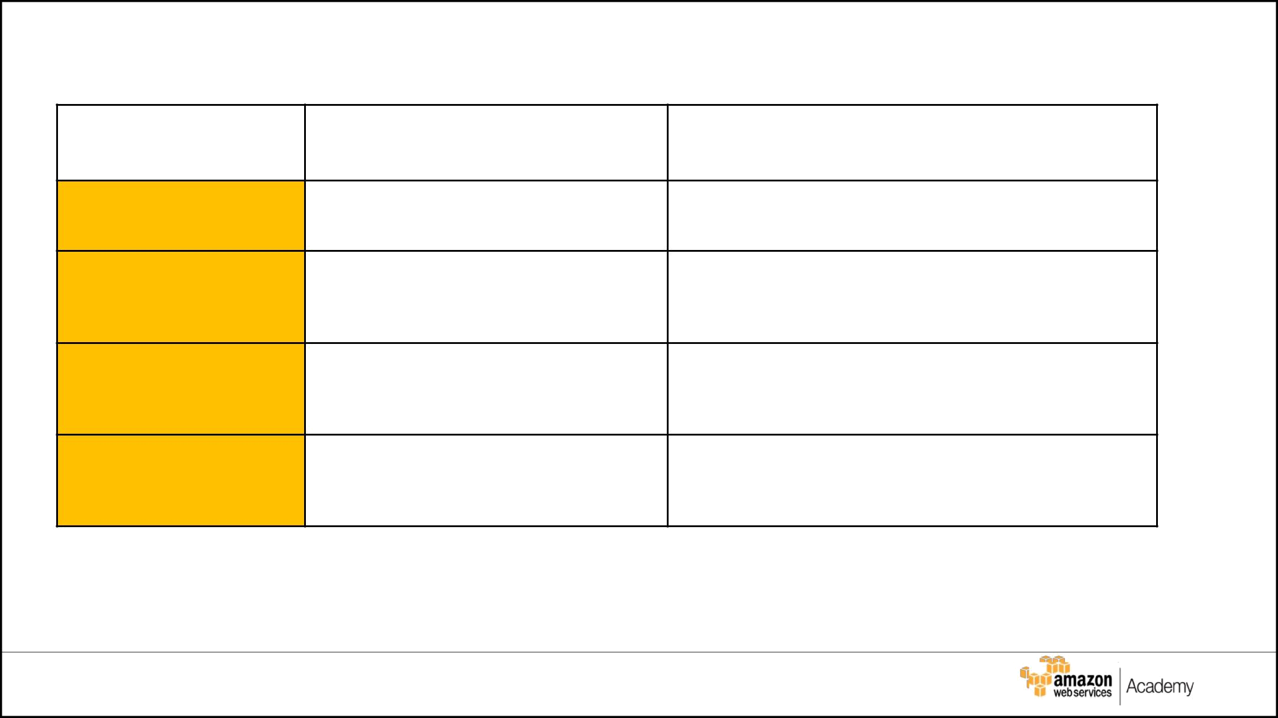
Users, Groups, and Roles

Group/Role # | Group/Role Name | Permissions

Group System Administrator AmazonEC2 and S3 FullAccess

Group Database Administrator AmazonRDSFullAccess

Amazon EC2, S3, RDS list and read access
Group Monitor

Role group manager Administrator Access

© 2017, Amazon Web Services, Inc. or its Affiliates. All rights reserved. ₁₉

Password Policy

Requirement | Solution
Should be at least 8 characters and | Go to aws iam account setting, it allows to edit all of the password attributes, include Minimum password length and Password must meet complexity requirements.
have 1 uppercase, 1 lowercase, 1
special character, and a number.
Change passwords every 90 days and | Go to aws iam account setting, it allows to edit Enable password expiration and Prevent password reuse.
ensure that the previous three
passwords can’t be re-used.
Administrator sign-in to the AWS | Go to aws iam user, it allows to create a user to requires the user of virtual MFA.
Management Console requires the
use of Virtual MFA.
All administrators require | Go to aws iam user, it allow to add a user Select Programmatic access and AWS Management Console access.
programmatic access

© 2017, Amazon Web Services, Inc. or its Affiliates. All rights reserved. ₂₀

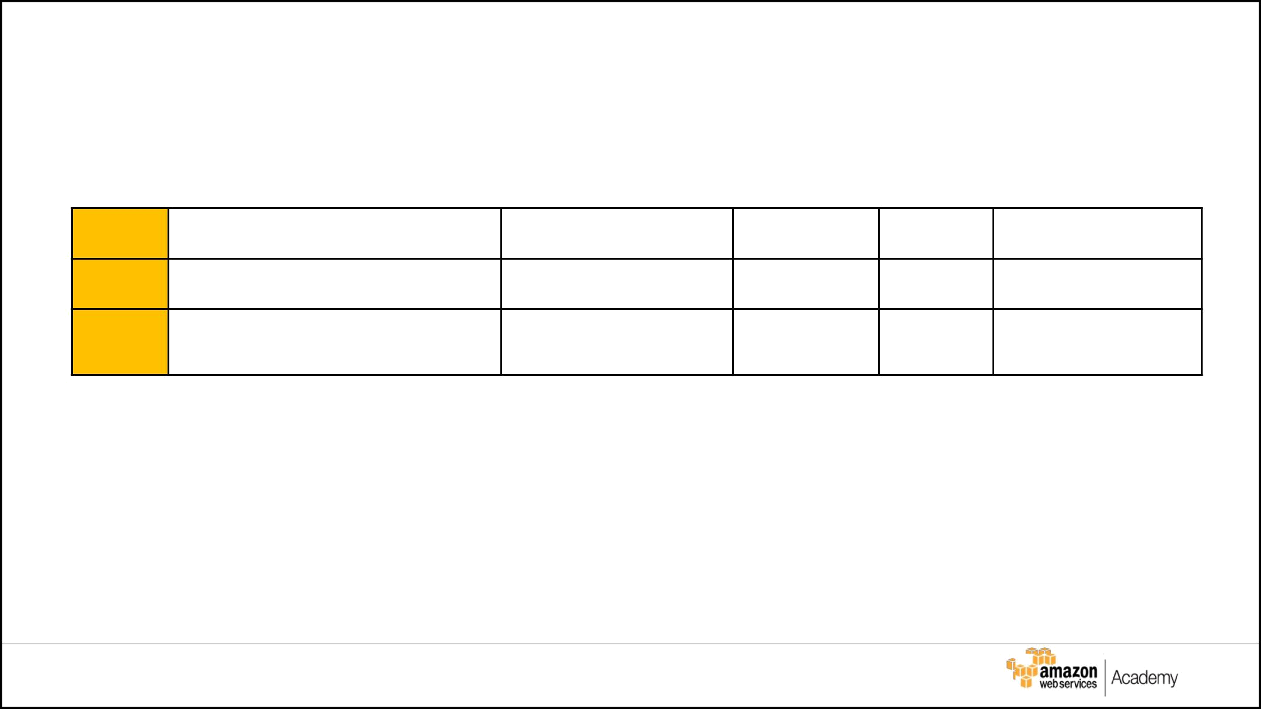

VPC | Region | Purpose | Subnets | AZs | CIDR range

1 Ireland enables to launch AWS 4 private subnet 3 availability zones 10.0.0.0/16
resources into a virtual 4 public subnet
network that we've defined
2

© 2017, Amazon Web Services, Inc. or its Affiliates. All rights reserved. ₂₁

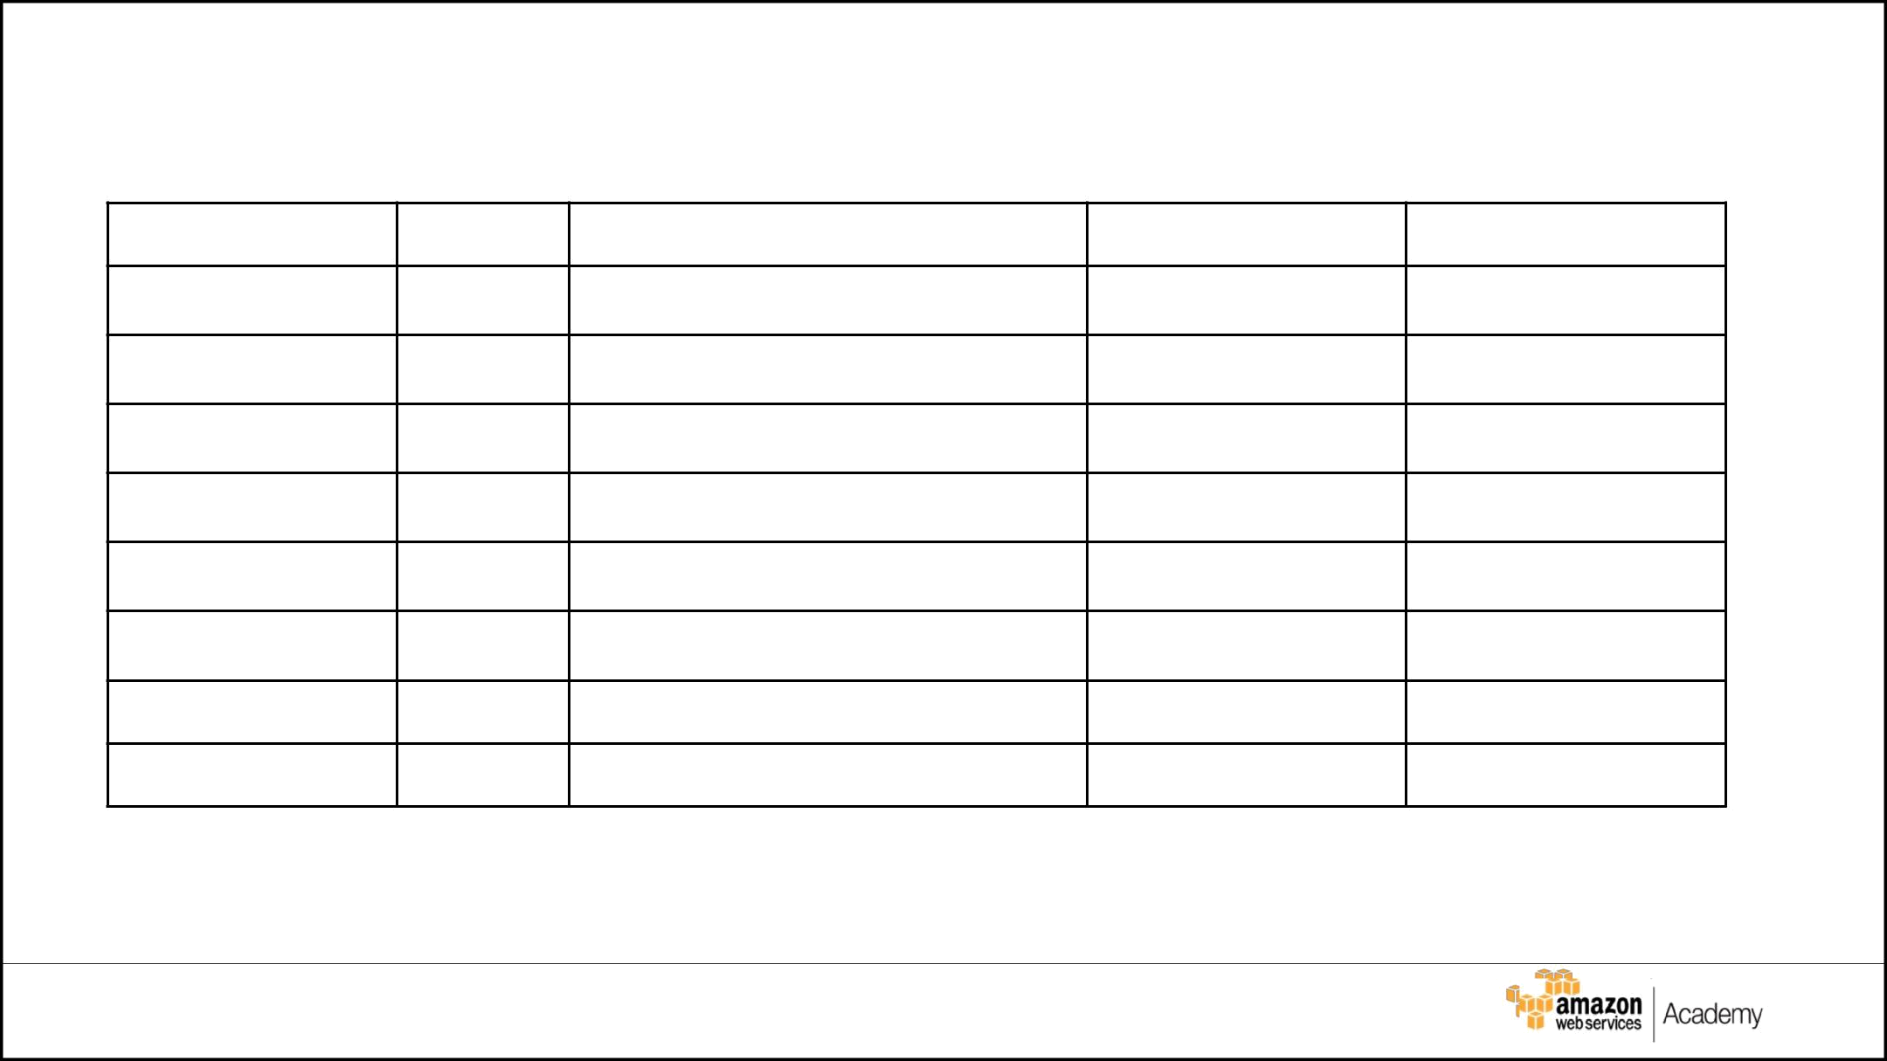
Production Subnet Details

Subnet Name | VPC | Subnet type (Public/private) | AZ | Subnet Address

#1
Pvsubnet1
#1

#1

#1

#1

#1

#1

#1

© 2017, Amazon Web Services, Inc. or its Affiliates. All rights reserved. ₂₂

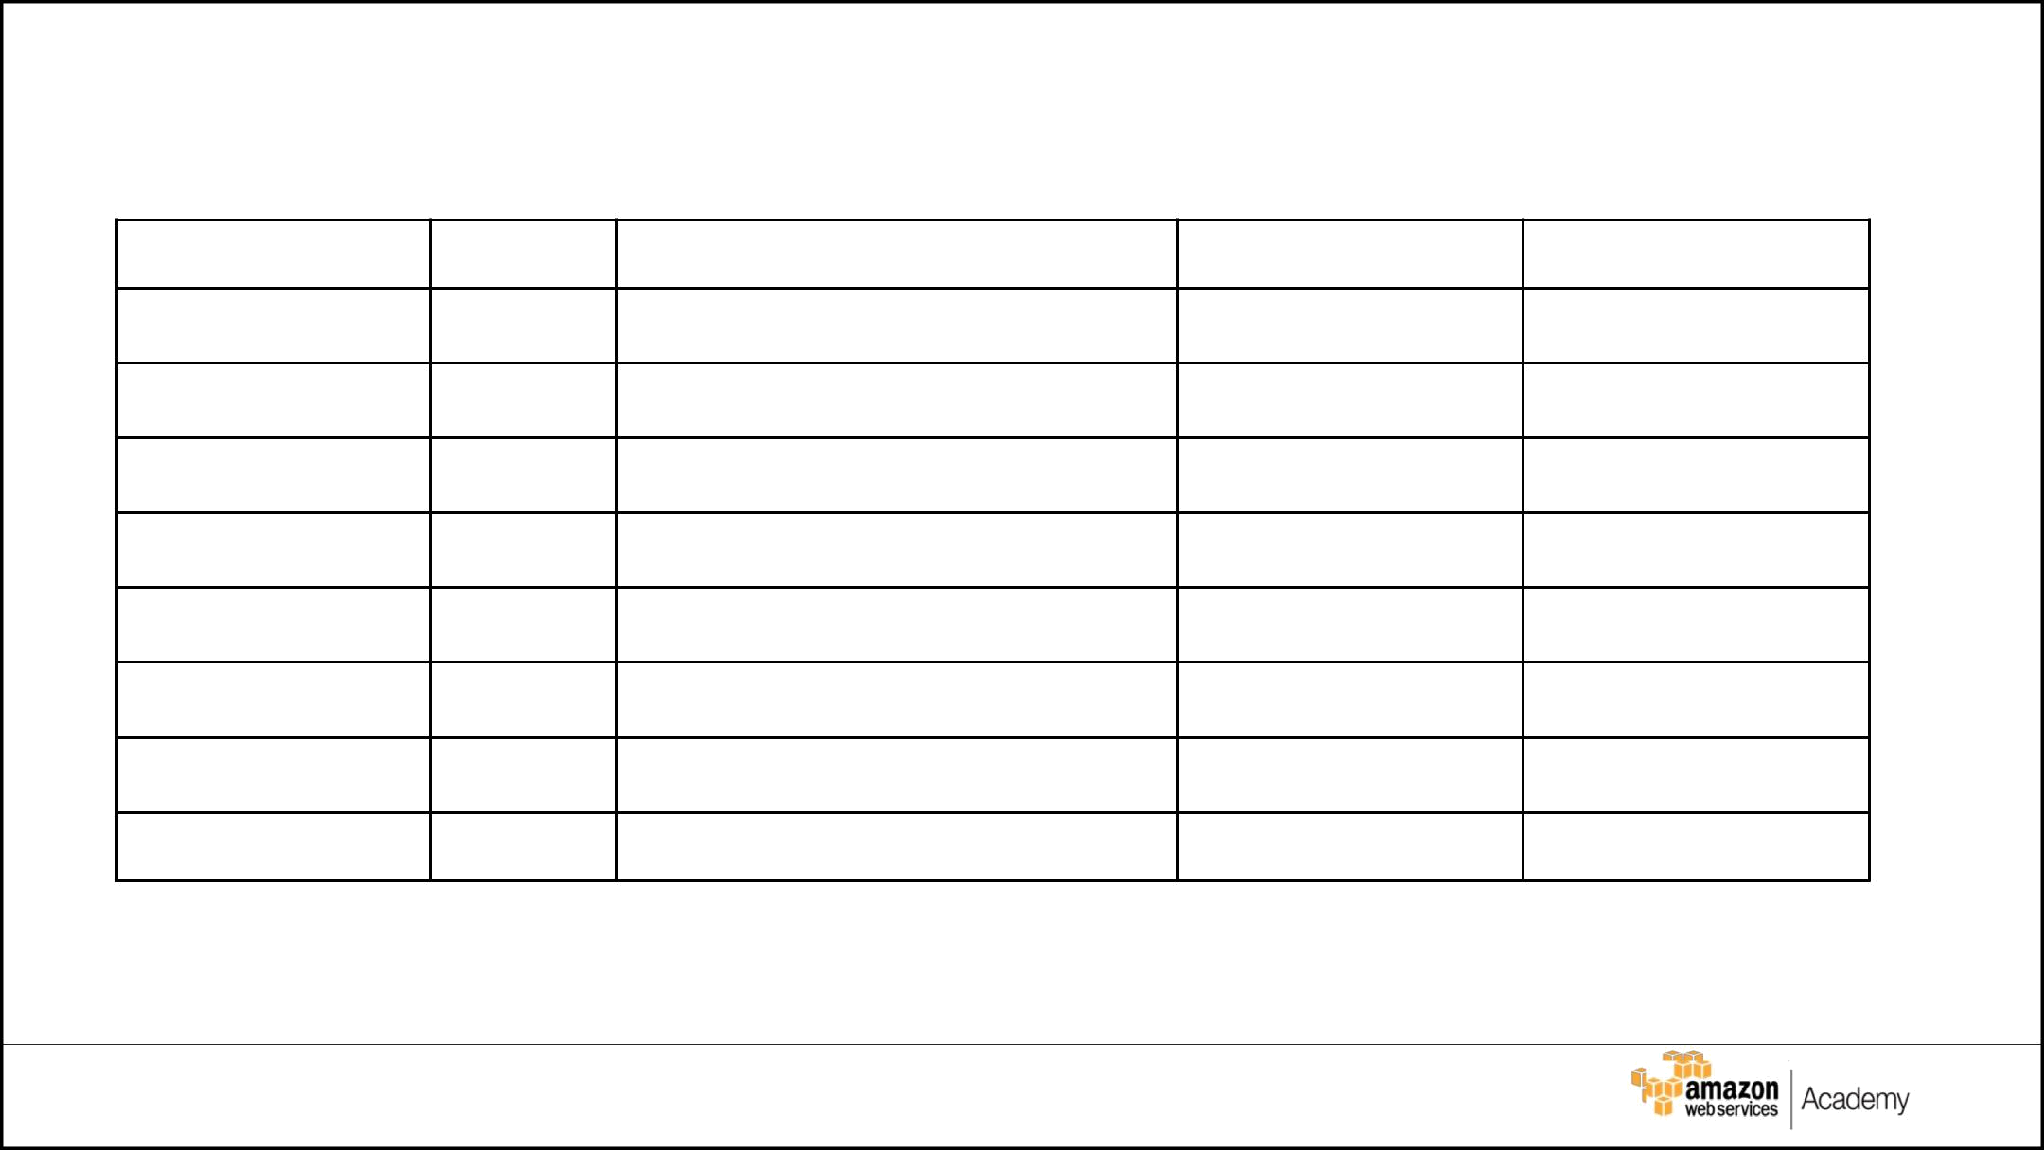
Test/Dev Subnet Details

Subnet Name | VPC | Subnet type (Public/private) | AZ | Subnet Address

#2

#2

#2

#2

#2

#2

#2

#2

© 2017, Amazon Web Services, Inc. or its Affiliates. All rights reserved. ₂₃

Instance Details

Describe the type, size, and justification for the instances you will use for each tier.

Tier | Tag* | OS | Type | Size | Justification | # of | User
 |  |  |  |  |  | instances | Data?
Web | Key = Name
Web | Value = web-tier
App | Key = Name
App | Value = app-tier
DB | Key = Name
DB | Value = db-tier
* Tags must be configured as shown to meet the lab objectives

© 2017, Amazon Web Services, Inc. or its Affiliates. All rights reserved.

Load Balancer and Instance Security Group Detai

Load | Name* | External | Subnets | SG Name* | Rule | Source
Balancer |  | /Internal
For Web | web-elb | Network Load Balancer | publicSubnet1 | web-elb-sg | TCP(HTTP 80) | 0.0.0.0/0::/0
Tier
For App | app-elb | Application Load Balancer | PublicSubnet2 | app-elb-sg | TCP(22 (SSH)) | 0.0.0.0/0::/0
Tier
 | Elastic Load  Balancer | Elastic Load  Balancer | admSubnet1 | app-elb-sg | TCP(22 (SSH)) | 0.0.0.0/0::/0
For designer

Instance Tier | SG Name* | Rule | Source
Web Tier | web-tier-sg | TCP(HTTP 80) | 0.0.0.0/0::/0
App Tier | app-tier-sg | TCP(22 (SSH)) | 0.0.0.0/0::/0
Database Tier | db-tier-sg | TCP(1433 (MS SQL))  TCP(HTTP 80) | 0.0.0.0/0::/0

* Names must be configured as shown to meet the lab objectives

© 2017, Amazon Web Services, Inc. or its Affiliates. All rights reserved. ₂₅

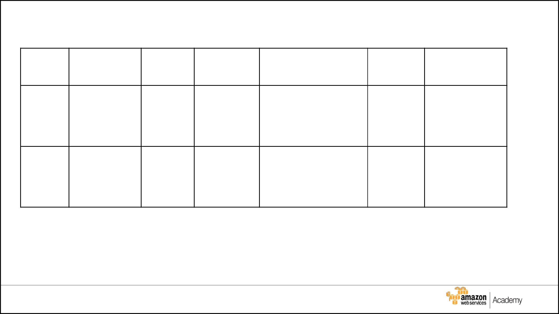
Auto Scaling Launch Configuration

Tier | OS | Type | Size | Configuration | Role | Security
 |  |  |  | Name* |  | Group

Web | WebTier

App | AppTier

* Name must be configured as shown to meet the lab objectives

© 2017, Amazon Web Services, Inc. or its Affiliates. All rights reserved. ₂₆

Auto Scaling Group

Tier | Launch | Group | Group | VPC | Subnets | ELB | Tags
 | Configuration* | Name* | Size
Web | WebTier | WebTier | 1 | vpc-ces33er | webSubnet | web-elb | Web
App | AppTier | AppTier | 1 | vpc-ces33er | appSubnet | app-elb | App

* Names must be configured as shown to meet the lab objectives

© 2017, Amazon Web Services, Inc. or its Affiliates. All rights reserved. ₂₇

Auditing Options

Q. How do you configure an account to create an audit trail for all executed API calls?

____________________________________________

Q. Where do you save your logs?

____________________________________________

© 2017, Amazon Web Services, Inc. or its Affiliates. All rights reserved. ₂₈

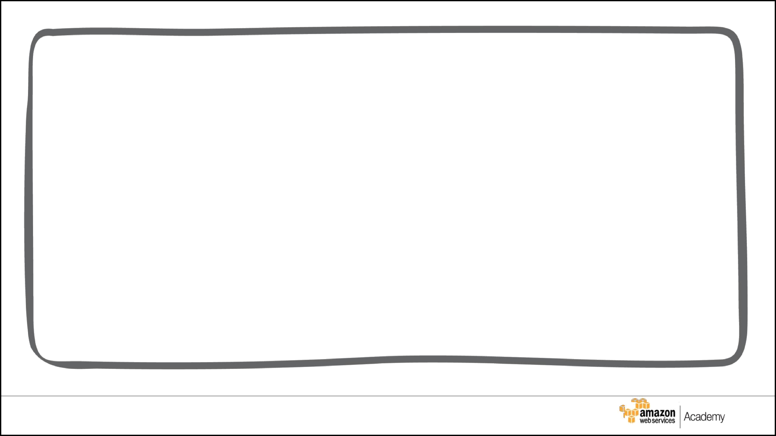
© 2017, Amazon Web Services, Inc. or its affiliates. All rights reserved.

This work may not be reproduced or redistributed, in whole or in part, without prior written permission from Amazon Web Services, Inc. Commercial copying, lending, or selling is prohibited.

Errors or corrections? Email us at aws-course-feedback@amazon.com. Other questions? Contact us at

https://aws.amazon.com/contact-us/aws-training/.

All trademarks are the property of their owners.

29

